**SHWOZ**



Railway Train System Simulation

Track Controller

Software/Hardware Design

By Derrick Ward

**Use Cases**

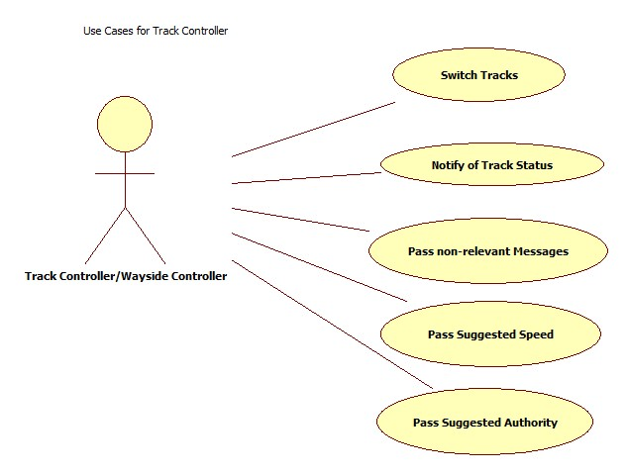

**Component Architecture**

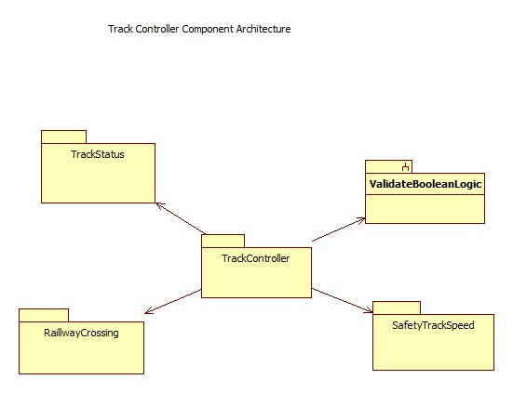

**Class Diagram**

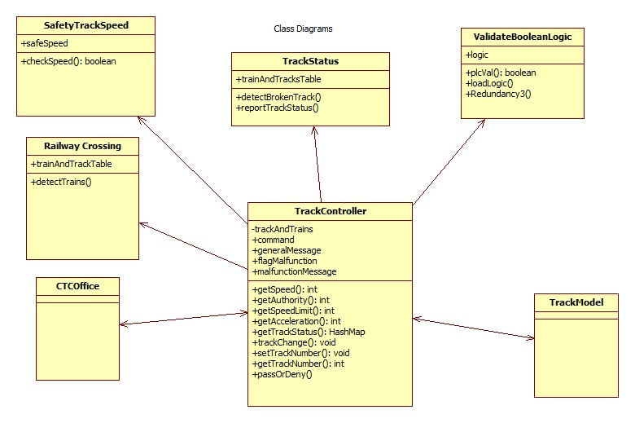

**Sequence Diagram**

